Exploring Diagonals and Triangles in a Rectangular Prism
Subject: Mathematics/Geometry
Grade Level: 7-9
Duration: 1 Hour
Objective:
- Students will use a 3D geometry simulator to construct a labeled rectangular prism.
- Students will draw and identify all the diagonals within the rectangular prism.
- Students will identify and name the triangles formed by these diagonals.
Materials:
- Computers with 3D geometry simulator software (https://play.creaticode.com/projects/a744f73930ab290afd013931/)
- Projector or interactive whiteboard for demonstration
- Worksheets for noting down observations and sketches
- Pencils and erasers
Introduction (10 minutes):
- Overview: Introduce the concept of a rectangular prism and its properties.
- Diagonal Exploration: Briefly explain what diagonals are in the context of 3D shapes, emphasizing their role in forming triangles within the shape.
- Software Demonstration: Demonstrate how to use the 3D geometry simulator to create a rectangular prism and label its vertices as ABCDEFGH.
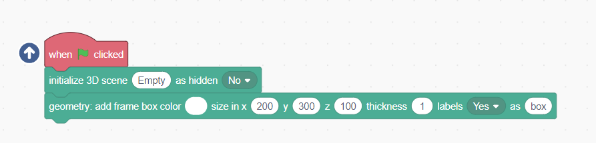
Activity Part 1 - Constructing the Prism (15 minutes):
- Student Exploration: Students will use the 3D geometry simulator to construct their own rectangular prism and label its vertices correctly.
- Guidance: Circulate to assist with any technical issues and to ensure correct labeling of vertices.
Activity Part 2 - Drawing Diagonals (15 minutes):
- Diagonal Instruction: Explain how to identify and draw diagonals in the rectangular prism. Ensure students understand to look for diagonals on faces as well as through the volume of the prism.

- Drawing Diagonals: Students will draw in all the possible diagonals they can find within their rectangular prism model.
- Make points: add points on the picture to mark intersections of diagonals.

Activity Part 3 - Identifying Triangles (15 minutes):
- Triangle Identification: Instruct students to identify and name all the triangles formed by the diagonals in the prism. Draw them in the picture using a different color for each.
Sample started project:
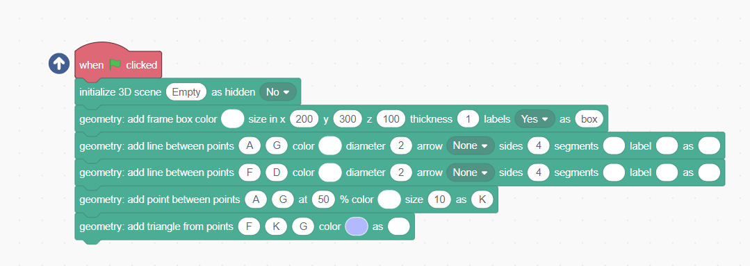
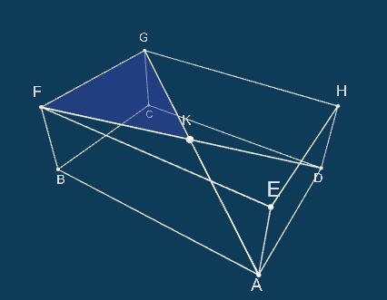

- Recording Findings: Students should record the names of these triangles and sketch them on their worksheets.
Conclusion (5 minutes):
- Review and Discuss: Bring the class together to discuss their findings. Highlight the different types of triangles that can be formed in a rectangular prism.
- Real-World Connection: Briefly discuss the importance of understanding geometric shapes and their properties in fields like architecture, engineering, and design.
Assessment:
- Evaluate students based on their participation and the accuracy of their rectangular prism models.
- Review their worksheets for correct identification and naming of triangles.
Extensions:
- Challenge students to calculate the angles of the triangles they have identified.
- Introduce other 3D shapes and ask students to explore diagonals and triangles in these new shapes.
Note: Ensure that all students are comfortable using the 3D geometry simulator software. It might be helpful to have a tutorial session or guide available for students who are less familiar with such software.

